**CREATE A DATABASE IN CLOUDANT DB**

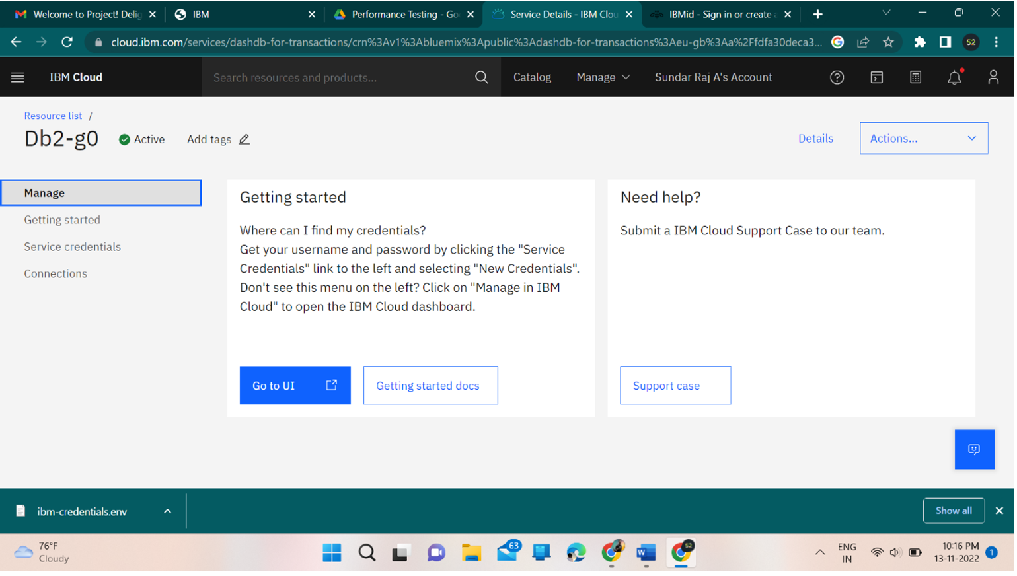

**CREATING A DATABASE IN CLOUDANT DB SUCCESSFULLY**